Duncan S Wilson  
Homework #3   
February 22, 2015

1. Reproduce Fig. 3.5 from *Elements of Statistical Learning*

This is done by sub-setting the prostate cancer data followed by performing linear regression over the subsets of the data, and finally plotting their residual sums squared.

This is the reproduction graph:

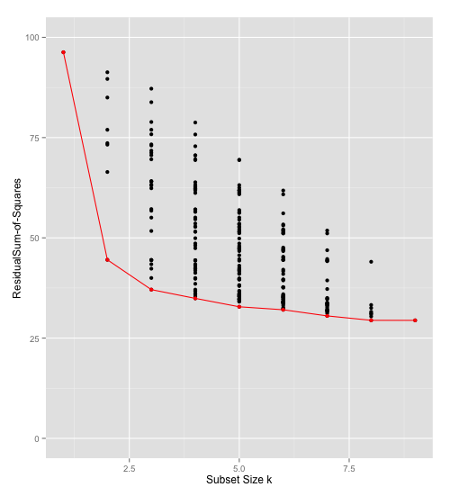

1. Perform Ridge Regression over the prostate cancer data:

To find the best β vector of coefficients, you multiply the β vector by a λ term in the error equation. As λ grows larger it penalizes the larger coefficients and shrinks them all toward zero.

As shown by the equation below:

$$argmin\left.\left\{\sum_{i=1}^{N}{{(y_{i}-β_{0}- \sum_{j=1 }^{p}{x_{ij}})}^{2}}\right.+ λ \sum_{j=1}^{p}{{β_{j}}^{2}}\right\}$$

When there are highly correlated variables in a model, their coefficients can become hard to determine and variance may grow. This method of penalizing, or weight decay, can be used to counteract that.